Guide for connecting a Laptop
To Operate the Television:
To power on the display, use the button labeled “Power”

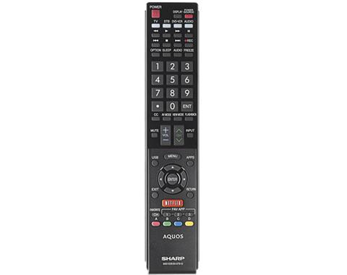
Tap the “Input” button to switch between Laptop and Polycom.

To Connect a Laptop:

- Ensure the TV is powered on and set to “Laptop” input.
- Connect the laptop using the VGA or HDMI cable from the table.*
- Be sure to send the signal, for Windows laptops it is usually 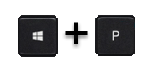key combination.

*You may require an adapter if your laptop is not fitted with the provided connector

