Guide to setting up zoom conferencing
To Operate the Television:

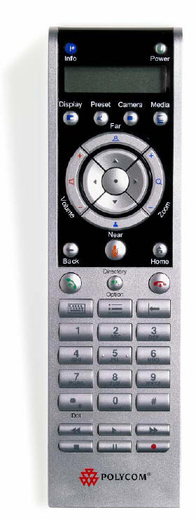
Use the arrow keys to adjust the camera angle.
Use the # key to bring up the Keypad for entering the Meeting ID.
Use the Power key to boot the Polycom system. The camera will turn around to show the system is getting ready.

To Connect Polycom/Zoom:
- Ensure the TV is powered on and set to “Polycom” input.
- Choose “ZoomEast” from Favorites or dial provided IP by using “Make a Call.”
- Enter the Meeting ID and passcode to join your Zoom meeting.**

*You may require an adapter if your laptop is not fitted with the provided connector
**Press the “#” sign to bring up the keypad for entering your Meeting ID/passcode

